**IoT-Based People Counting System Utilizing Web Cameras: A Technical Description**

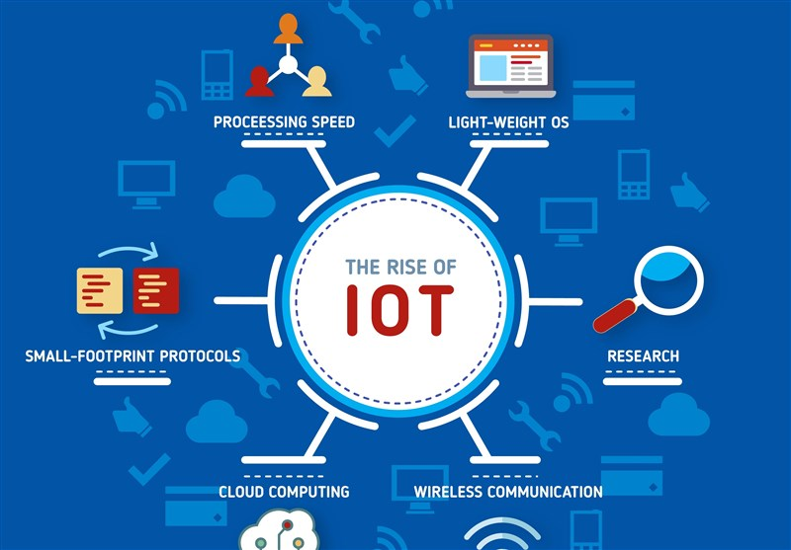

Table of Contents

***1.0*** ***Introduction*** 3

***2.0*** ***Design Evolution*** 5

***2.1*** ***Initial Concept*** 5

***2.3*** ***Image Processing Techniques*** 6

***2.4*** ***OpenCV Integration*** 7

***2.5*** ***Data Storage and Analysis*** 7

***2.7*** ***Power Management*** 8

***2.8*** ***Iterative Testing and Evolution*** 8

***3.0*** ***Technical Description of Traffic Counting System [Level I]*** 8

***3.1*** ***Part By part Description of Traffic Counting System [Level 2]*** 9

***3.2*** ***Part By part Description of Traffic Counting System [Level 2]*** 9

***3.2.1*** ***Major Assembly #1: Traffic Counting System [Level 3]*** 10

***3.2.1.1*** ***Sub-Assembly #1: Traffic Counting System [Level 4]*** 11

***3.2.1.2*** ***Sub-Assembly #2: Traffic Counting System [Level 4]*** 11

***3.2.2*** ***Major Assembly #2: XYZ [Level 3]*** 11

***3.3*** ***Cycle of Operation [Level 2]*** 12

***3.3.1*** ***Operating Traffic Counting System [Level 3]*** 12

***3.3.2*** ***Maintaining Traffic Counting System [Level 3]*** 13

***3.4*** ***Value to User [Level 2]*** 13

## ***Introduction***

People counting systems play a pivotal role in various environments, offering valuable insights into occupancy levels, resource allocation, and operational efficiency. In the context of makerspaces, where collaboration and creativity thrive, accurately tracking the number of individuals entering and exiting the facility is essential for effective management and fostering a conducive environment. This project aims to develop an innovative people counting system specifically designed for makerspaces, utilizing web cameras and desktop-based Python software instead of traditional IoT devices and Raspberry Pi, addressing the challenges faced by administrators, and enhancing the user experience.

The purpose of this project is to create a comprehensive people counting system that leverages web cameras and computer vision technology to accurately track the occupancy of makerspaces. By integrating web cameras and advanced image processing algorithms, the system will collect real-time data on entry counts, enabling informed decision-making for facility management and resource planning. The goal is to optimize space utilization, automate the people counting process, and streamline operations, creating a welcoming and productive space for makers and innovators.

To achieve the project's purpose, several design criteria have been established. First, the system must accurately count the number of people entering the room, with minimal discrepancies compared to manual verification or other reliable counting methods. Additionally, the system should avoid double counting of individuals entering and leaving within the same working day. This will be validated through tests involving multiple entries and exits, ensuring the system tracks unique individuals accurately. Furthermore, the counter should reset at midnight to start counting for a new day, and the system should have the capability to export the count results in a .CSV file format. Compatibility with standard spreadsheet software and the generation of accurate data fields are crucial in this aspect.

Reliability is a key measurement of success for this project. The system must operate reliably with minimal downtime or failures, ensuring continuous and uninterrupted tracking of occupancy levels. Additionally, data security is of utmost importance, and sensitive data collected by the system must be secure and protected. Robust security measures, including encryption, access controls, and secure communication protocols, will be implemented to address vulnerabilities and safeguard privacy.

User-friendliness and meeting user expectations are essential considerations. Gathering user feedback through surveys or interviews will provide insights into user satisfaction, ease of use, clarity of data presentation, and overall user experience. Incorporating user input into system design and functionality will enhance the adoption and effectiveness of the people counting system.

The relevance of this study extends beyond the immediate context of makerspaces. The development of a web camera-based people counting system can benefit various industries, such as event management, retail, and transportation, where accurate occupancy tracking is crucial. By automating the counting process and providing reliable data, this solution can contribute to optimizing resource allocation, improving operational efficiency, and complying with regulatory requirements.

This document will be organized as follows: In Chapter 2, we will review the existing literature and related works in the field of people counting systems, focusing on their applications and technological approaches. Chapter 3 will detail the methodology adopted for this project, including the system architecture, hardware and software components, and data collection procedures. Chapter 4 will present the implementation and testing phase, outlining the steps taken to develop the web camera-based people counting system and evaluating its performance against the design criteria. Finally, Chapter 5 will summarize the findings, discuss the implications, and provide recommendations for further improvements.

The scope of this investigation includes the development of a web camera-based people counting system specifically designed for makerspaces. The project aims to address the challenges of accurately tracking occupancy levels in makerspaces and optimizing resource allocation. However, it is important to note that this project does not encompass the design and construction of the physical makerspace itself, nor does it focus on broader facility management aspects unrelated to occupancy tracking. The investigation will primarily focus on the development and evaluation of the people counting system, its functionality, accuracy, and user experience.

## ***Design Evolution***

The "Design Evolution" chapter offers a comprehensive exploration of the iterative design process that culminated in the development of the people counting system, harnessing the synergy between web cameras and Python scripts running on a desktop platform. Serving as a precursor to the forthcoming technical presentation, this chapter delves into the nuanced progression of ideas and considerations that decisively influenced the ultimate design.

# ***Initial Concept***

The project's inception revolved around conceptualizing an innovative people counting solution that harnessed the capabilities of web cameras and a dedicated Python script optimized for robust image analysis on a desktop platform. The core objective was to create a solution that was both cost-effective and inherently scalable, while maintaining a high level of accuracy in quantifying individuals within designated spaces.



Figure 1

* 1. ***Hardware Selection***

The meticulous hardware selection phase embarked upon an exhaustive journey of research and scrutiny to identify components that seamlessly aligned with the project's core objectives. This process involved judicious analysis that sifted through an array of contenders, bearing the litmus test of compatibility, functionality, and feasibility. Through rigorous evaluation, web cameras emerged as the pivotal component of the hardware ensemble, chosen due to their suitability for the project's spatial considerations, capability for real-time video data capture, and seamless integration with Python scripts running on desktop platforms for precise people detection. This choice was complemented by the strategic selection of web camera models tailored to capture real-time video feeds essential for accurate people counting. The utilization of web cameras evolved into the cornerstone of the system's architecture, embodying accuracy, scalability, and innovation through meticulous technology integration.

# ***Image Processing Techniques***

Precision served as the guiding principle throughout an extensive exploration of diverse image processing methods, each subjected to meticulous scrutiny for its applicability in identifying and tracking individuals within dynamic video streams captured by web cameras on a desktop platform. A range of methodologies, including background subtraction, contour detection, and motion analysis, underwent rigorous evaluation. Their effectiveness was assessed across a spectrum of lighting conditions, noise tolerance levels, and computational efficiency benchmarks, ensuring the selection of techniques that align with the project's pursuit of accurate people detection and tracking using web camera feeds.

# ***OpenCV Integration***

The design journey's fortification materialized through the seamless integration of OpenCV, a renowned open-source computer vision library. This integration facilitated the deployment of sophisticated image-processing algorithms within the Python script, establishing a robust foundation for nuanced video analysis, object detection, and precise tracking using web cameras on a desktop platform. Iterative refinement further honed the design's finesse by calibrating OpenCV parameters to enhance detection accuracy and overall system reliability, underscoring the project's dedication to harnessing cutting-edge technology with web cameras.

# ***Data Storage and Analysis***

The project's success critically depends on strategic data management, entailing a thorough examination of various storage solutions. Options ranged from on-device storage to cloud-based paradigms and seamless integration with external databases, all with a focus on efficiently handling data from web camera feeds on a desktop platform. The chosen strategy underwent rigorous evaluation against criteria encompassing data security, accessibility, and real-time analytical capabilities. This meticulous approach culminated in the implementation of a tailored solution aligned with the project's objectives, ensuring that the collected data from web cameras serves as a valuable resource for informed decision-making.

* 1. ***User Interface and Visualization***

Enhancing user engagement and interaction spurred the development of an intuitive, user-centric interface designed to accommodate configuration and data visualization requirements within the context of web cameras on a desktop platform. The comprehensive evaluation encompassed options ranging from command-line interfaces to sophisticated web-based dashboards. Ultimately, the choice favored a web-driven dashboard, providing users with seamless access to system settings, real-time headcounts, and graphical representations of historical data captured by web cameras. This fusion of functionality and aesthetics ensures that users can effortlessly interact with the system, facilitating better insights and informed actions.

# ***Power Management***

With energy efficiency as a guiding principle, the design foresight encompassed adept power management strategies aligned with the energy-efficient nature of running the Python software on a desktop platform instead of Raspberry Pi. From judicious utilization of power-saving modes to strategic scheduling mechanisms, a range of strategies were employed to amplify system uptime while ensuring prudent energy consumption. This emphasis on power management reflects the holistic approach taken in the design, considering both functionality and sustainability in the context of web cameras and desktop operation.

# ***Iterative Testing and Evolution***

An iterative testing and evolution loop was a hallmark of the design journey, tightly woven into each developmental phase. Rigorous real-world simulations became the crucible for evaluating the system's accuracy and reliability across dynamic scenarios on a desktop platform using web cameras. Importantly, the feedback loop from stakeholders and users assumed paramount significance, catalyzing design refinements and iterative enhancements. This iterative approach underscores the commitment to a solution that aligns with evolving needs and ensures continuous improvement while relying on web cameras and desktop-based Python software rather than Raspberry Pi.

# ***Technical Description of Traffic Counting System [Level I]***

The Traffic Counting System is a comprehensive solution meticulously crafted to achieve precise and efficient counting of people entering a room. It utilizes a desktop platform with a web camera for capturing and processing visual data, employing a custom Python script for real-time traffic counting and tracking.

# ***Part By part Description of Traffic Counting System [Level 2]***

The Traffic Counting System is a combination of hardware and software components designed to automate the process of counting individuals as they enter a room. The system employs a Raspberry Pi 3B+ as the central processing unit, a Module 3 Camera for capturing visual data, and a custom Python script for real-time traffic analysis. The key objective of the system is to provide accurate and reliable visitor count data for various applications, including resource optimization and crowd management.

Figure 2

# ***3.2 Part By part Description of Traffic Counting System [Level 2]***

Major Assembly #1 includes the core components responsible for capturing, processing, and analyzing the traffic data. It consists of:

# ***Major Assembly #1: Traffic Counting System [Level 3]***

Raspberry Pi 3B+: Serving as the central processing unit, the Raspberry Pi runs the custom Python script that processes the camera feed and performs real-time traffic counting.

Module 3 Camera: The high-resolution camera module captures live video feed of the room's entrance area, which is processed by the Raspberry Pi.

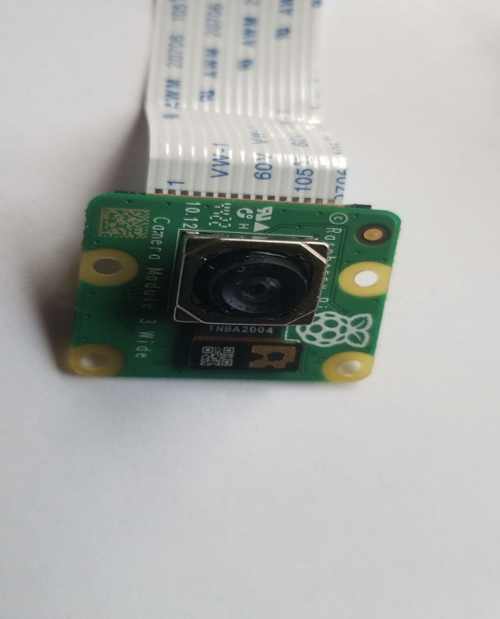Python Script: A custom Python script is responsible for image processing, object detection, and real-time traffic counting. It utilizes libraries like OpenCV to analyze the camera frames and identify individuals entering the room.

Figure 3

# ***Sub-Assembly #1: Traffic Counting System [Level 4]***

Sub-Assembly #1 focuses on the Raspberry Pi 3B+ and its associated components. This includes power supply, connectivity interfaces, and system management.

Power Supply: The Raspberry Pi is powered by a suitable power source, ensuring stable operation.

Connectivity Interfaces: The Raspberry Pi interfaces with the Module 3 Camera and optionally with a display interface for real-time traffic count visualization.

System Management: The Raspberry Pi manages the execution of the Python script, data processing, and communication with external components.

# ***Sub-Assembly #2: Traffic Counting System [Level 4]***

Sub-Assembly #2 focuses on the Module 3 Camera and its related components. This includes lens, image sensor, and image data processing.

Lens and Image Sensor: The camera module is equipped with a lens and image sensor to capture high-quality visual data.

Image Data Processing: The captured visual data is processed using image processing techniques to detect and track individuals entering the room.

# ***Major Assembly #2: XYZ [Level 3]***

Major Assembly #2 in the Traffic Counting System encompasses critical components responsible for data processing, traffic analysis, and user interaction. It comprises:

Microcontroller Unit (MCU): A microcontroller unit, distinct from the Raspberry Pi, manages data processing and system control for traffic analysis. It efficiently handles data from the Module 3 Camera and interfaces with the Raspberry Pi for seamless coordination.

Data Processing Algorithms: Within this major assembly, sophisticated algorithms are executed on the MCU to process the captured camera frames. These algorithms include noise reduction, motion detection, and object tracking, contributing to accurate traffic counting.

Traffic Analysis Logic: The MCU implements specialized logic for traffic analysis. It interprets data from the object tracking algorithm and updates the traffic count in real-time, preventing errors due to duplicate counts.

Communication Interface: Major Assembly #2 interacts with Major Assembly #1 (Raspberry Pi) via a communication interface. This interface enables the exchange of data related to traffic count updates and system status.

User Interaction: Major Assembly #2 provides a user interface, either through an integrated display or remote access. This interface offers users the ability to view real-time traffic counts, historical data, and configuration settings.

Alarm System (Optional): Major Assembly #2 can be equipped with an alarm system that triggers alerts when predefined thresholds are exceeded. This feature is particularly valuable for crowd management and security applications.

# ***Cycle of Operation [Level 2]***

The Traffic Counting System operates through the following cycle of operation:

# ***Operating Traffic Counting System [Level 3]***

During the operation of the Traffic Counting System, the following sequence of events occurs:

Camera Feed Capture: The Module 3 Camera captures live video feed of the entrance area, where individuals enter the room.

Image Processing: The captured video frames are processed by the Python script using image processing techniques. The script applies object detection algorithms to identify human figures in the frames.

Object Tracking: Once identified, the system initiates object tracking to follow the detected individuals' movement within the frame.

Traffic Counting: The system increases the count for each detected individual entering the room. Object tracking helps avoid double counting as individuals move in and out.

Real-Time Display (Optional): If a display interface is connected, real-time traffic count data may be displayed for users to view.

1. ***Maintaining Traffic Counting System [Level 3]***

To maintain the efficient operation of the Traffic Counting System, the following steps are recommended:

Regular Calibration: Periodic calibration of the object detection and tracking algorithms ensures accurate counting in various lighting conditions and crowd densities.

Hardware Inspection: Regularly inspect the Raspberry Pi, Module 3 Camera, and associated components for physical damage or connectivity issues.

Data Management: Implement mechanisms to store and manage the traffic count data, allowing for historical analysis and trend prediction.

Software Updates: Keep the Python script and related libraries up to date to benefit from the latest advancements in image processing and counting techniques.

Backup and Recovery: Implement data backup strategies to prevent loss of valuable traffic count data in case of system failures.

# ***Value to User [Level 2]***

The Traffic Counting System offers several notable advantages to its users:

Accurate Traffic Counting: The system provides accurate real-time counts of individuals entering a room, assisting in crowd management and resource allocation.

Data-Driven Decision-Making: The traffic count data collected over time enables data-driven decision-making for optimizing staff allocation, space utilization, and event planning.

Operational Efficiency: By automating the counting process, the system reduces the need for manual counting efforts and minimizes human error.

Insightful Analytics: Users gain insights into peak visitor times, traffic patterns, and overall room occupancy, enhancing operational efficiency.

Customizability: The Python script can be tailored to specific requirements, allowing users to adapt the system to different environments and counting scenarios.